User Manual for Skylar Thompson Final Project – Burger Builder

Usage Instructions

1. Run the Program

Run the Burger Builder Program

1. Select Your Options

Only one option from the Bun, Cheese, and Meat sections can be selected at the same time

2.1. Select Your Bun Option

2.2. Select Your Cheese Option

2.3. Select Your Meat Option

2.4. Select Your Toppings Option(s)

Multiple options from the Toppings section can be selected at the same time

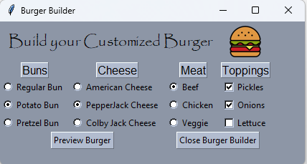

1. Click Preview Burger Button or Close Burger Builder Button

3.1. Close Burger Builder Button

Selecting Close Burger Builder Button will close the program

1. View Your Burger Preview

4.1. You can see the Price Breakdown of your burger and everything in it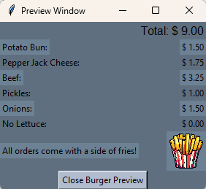

5. Close Burger Preview

After viewing the price breakdown select the Close Burger Preview Button to close the preview

6. Repeat or Close Burger Builder

Repeat previous steps if another burger is desired or select Close Burger Builder Button to close the program